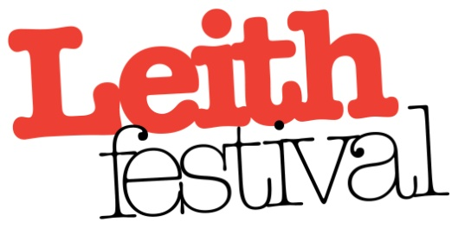
Leith Festival Association Ltd
1st floor, 17 Academy Street, Leith EH6 7EE
tel: 0131 629 1214
email: office @leithfestival.com
Scottish Charity No: SC036496
Companies House No: SC283758
Leith Festival Gala Day Stall Application Form 2020
Welcome! Leith Festival Gala Day takes place on Leith Links on Saturday 13th June 2020. A pitch will be allocated to you on application.
Please complete and return this form with full fee (BACS, cash to the office or cheque):
All cheques should be made payable to Leith Festival Association and returned to:
Leith Festival Association, 1st floor, 17 Academy Street, Leith, EH6 7EE
BACS: Leith Festival Assoc
sort code 80 02 71
acct no 00488748
(use GALA/your organisation name as reference please)
______________________________________________________________________________
ORGANISATION NAME:
NAME:
ADDRESS:
POST CODE:
CONTACT NUMBER:
EMAIL ADDRESS:
VEHICLE REGISTRATION NUMBER (for purposes of parking on Leith Links):
STALL PRICING (please tick one)
Standard Stall Pitch £50.00 per pitch (3m x 3m)
FOOD STALLS BOOKED OUT
Description of what you will be selling / what service you will be providing at your stall:

Terms and Conditions
When you pay the registration fee (and no booking will be accepted without it), you are agreeing to the following conditions:
Times: Setting up time is from 7.00am. No vehicle movement will be allowed on Leith Links between 10am and 5.00pm. Trading will cease at 4.30pm. Please note no vehicles to move until after 5pm.
Vehicles: Each stall will be allocated a designated parking space for one vehicle. The stall pitch will be allocated on arrival, a steward will guide you to your allotted space. Vehicle access by LINKS PLACE only. Postcode EH6 7EZ.
Your Stall: Each stall pitch allocated is measured for you at 3m x 3m. Stallholders must provide their own tables, rails, coverings and anything else required for their day’s trading. There is no electricity, gas supply or running water on Leith Links. Please ensure that you have all relevant electrical certificates and food trading licenses available for inspection.
Rubbish: All stallholders are responsible for the cleanliness of the immediate area surrounding their stall and for tidying up and disposing of their own rubbish (especially food waste). Leith Festival Association will provide wheelie bins for litter from the general public. There is a ban on the sale of ‘silly string’ and ‘stink bombs’.
Food: Because of strict regulations on food safety and hygiene, no stallholder may sell food or drink without permission from the Leith Festival Association. You must also comply with the Food Hygiene Act 1995 and the Food Safety Act 1990. Please enclose copy of your certification with your booking. An inspector from the Department of Environmental Health will be present on the day, and stalls will be monitored.
Cancellation: If after paying for a stall, you are unable to attend, please inform Leith Festival at least TWO WEEKS before Saturday 13th June 2020 and you will receive a refund less £10.00 cancellation fee. Cancellations after this date will incur full stall fee and not be refunded.
Stall Pitch Form Agreement
Please make sure you have read and understood the terms & conditions on this form in full and agree to its terms and deadlines before signing.
Name:
Signature:
Date:
Leith Festival Association cannot accept responsibility for any item/s lost or stolen from your stall.
Please do not leave goods and valuables unattended at anytime throughout the day.
Leith Festival sets all terms & conditions to ensure a safe and happy day for public, stallholders and volunteers alike. If any stallholder does not help us by complying with them in full, we reserve the right to decline their application and future applications.

